**Instructions on how to fix T Drive with Fortinet Client**

1. Type “**ncpa.cpl**” in the search bar in the bottom left hand corner near the Windows Icon like so.

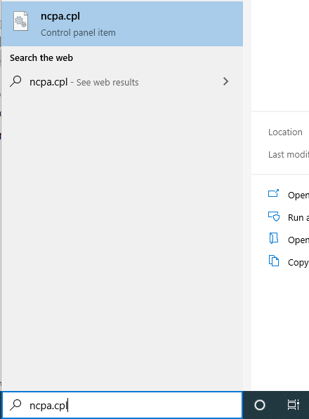

1. Hit enter and this screen should appear.

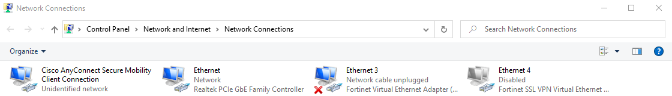

1. Right click on the Fortinet SSL VPN Virtual Ethernet adapter, than click on and it should open a menu like so.

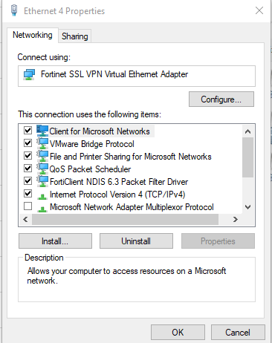

1. Scroll Down just a tad and uncheck the box labeled “Internet Protocol Version 6 (TCP/IPv6) So it appears like so.

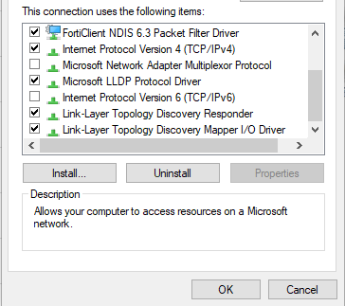

1. Once this is complete hit okay and you should now be able to connect to the T drive using the Forticlient VPN.